|  |  |  |
| --- | --- | --- |
| **THARAKA** | logo | **UNIVERSITY** |
|  | **COLLEGE** |  |

**SOFTWARE SYSTEM PROJECT**.

**THARAKA UNIVERSITY COLLEGE.**

**FACULTY OF PHYSICAL SCIENCE ENGINEERING AND TECHNOLOGY.**

**DEPARTMENT OF COMPUTER SCIENCE.**

**NAME**: Martin Karani

**REG NO:** EDST1/ 03351/21

**EMAIL:** karanimartin810@gmail.com

**ONLINE ATTENDANCE TRACKING SYSTEM**

**DECLARATION**

I declare that this project “ONLINE ATTENDANCE TRACKING SYSTEM” is work of Mugambi Martin Karani in partial fulfilment of the requirement for the award of the Diploma in Computer Science. I further declare that the work carried out by me in this project has not been submitted and will not be submitted, either in part or in full for the award of any degree or diploma in this institute.

Martin Karani Signature…………….. Date……………………….

Department of computer science

THARAKA UNIVERSITY COLLEGE

**APPROVAL**

This project was submitted to the university of Applied science and technology for online attendance tracking system with approval of Madam Evah Njeru.

Sign……………………………….. Date………………………………………….

Department of Computer science.

**DEDICATION**

I dedicate this project to the Almighty God the creator of the universe, my source of knowledge, wisdom and knowledge since He has been the source of strength throughout this project. I also dedicate this work to my family; my dad John and my mum Tabitha for their great support and their value cannot be quantified. May the Almighty God bless you.

**ACKNOWLEDGEMENT**

I would like to express my special thanks of gratitude to my lecture (madam Evah) and also the principle (Prof. Muriungi) who gave me the golden opportunity to do this project (ONLINE ATTENDANCE TRACKING SYSTEM), which helped me to do a lot of research thus coming up to know about so many things.

Secondly, I would also like to thank my friends who really helped me in coming up with such idea of finalizing this project in time.

I am also over helmed in all humbleness and gratefulness to acknowledge my depth to all those who have helped me to put these ideas as well as having something concrete and firm.

**TABLE OF CONTEN**

Title page……………………………………………………………………………………………………………(i)

Declaration ……………………………………………………..………………………………………………..(ii)

Approval……………………………………………………………………………………………………………(iii)

Dedication ………………………………………………………………………………………………………..(iv)

Acknowledgement ……………………………………………………………………………………………(v)

Abstract …………………………………………………………………………………………………………..(vi)

Problem statement …………………………………………………………………………………………(vii)

**Chapter 1……………………………………………………………………………………………………(viii)**

1. Introduction …………………………………………………………………………….. a

1.2Objective…………………………………………………………………………………. b

Methodology………………………………………

**Chapter 2………………………………………………………………………………….(ix)**

2.0 System analyses…………………………………………………..(a)

2.1 Introduction ……………………………………………………….. (b)

2.2 Existing System………………………………………………… (c)

2.3 Proposed System……………………………………………..(d)

2.4 Software Development Life circles ………………(e)

2.5 Feasibility Study ………………………………………….(f)

2.6 Economic Feasibility ………………………………..(g)

2.7 Technical Feasibility Study ……………………….(h)

2.8 Operation Feasibility ………………………………(i)

**Chapter 3 …………………………………………………………..……………..(x)**

3.0 Description of the proposed system………………………(a)

3.1 Advantages of the proposed System …………………….(b)

3.2 Requirement of Engineering ……………………………….(c)

3.3 Requirement of the Analysis …………………………….. (d)

3.4 System Design ……………………………………………………(e)

**Chapter 4 ………………………………………………………………………(xi)**

4.0 Implementations and Testing

4.1 Introduction

4.2 Implementations

4.2.1 Implementation choices

**Chapter 5…………………………………………………………………….(xii)**

Summary, Conclusion and Recommendation

5.1 Summary

5.2 conclusion

5.3 Recommendation

**ABSTRACT**

The project describes the problem of managing the number of attendances or absences in the academic environment.it is one of the most important factors of academic achievement. The project supports the idea of automated system over day-to-day handwritten attendance registries, in order to facilitate the process. The system itself comprises of a time keeping system that will register every student or teacher in a database. The database will be managed by the university so that the reports can be issued whenever they are needed on both physical and electronic format.

These reports can be used to create statistics and help the growth of the academic process related with students’ interest or attendance rate on certain classes.

The student attendance report based on monthly and consolidate will be generated.

**PROBLEM STATEMENT**

Online attendance tracking system is a software developed for daily student and workers attendance in schools, colleges and institute. It facilitates to access the attendance information of a particular student in a class. It also helps to maintain the accurate record and generate summarized student attendance reports for the students by applying various criteria. It keeps track to daily attendance, working hours, breaks, login and logout time.

**CHAPTER ONE**

**INTRODUCTION**

**1.O Introduction**

This chapter covers the objectives, scope and methodology of the project.

* 1. **OBJECTIVE**

**“**Online Attendance Tracking System” is a software developed for maintaining the attendance of the students on the daily bases in the institution. The staffs who are responsible in handling the unit will be also responsible in marking the attendance of the students in the class; whereby they will be given a separate user name and the password based on the unit they handle. The report of the student’s attendance on daily, weekly and monthly basis will be provided. The attendance eligibility criteria of the student will be maintained.

* 1. This system enables lecturer to add, view, make changes or delete on subject, classes, students and attendance accordingly. More over saving attendance records into the system will be more secured as compared to paper-based records.
  2. **AIMS AND OBJECTIVES**

**AIMS**

The aims of this project are to carry out a careful study of the existing system of attendance management and design a computerized method that will help to minimize storage space and keep all records in the computer for future references.

**Unique and special features**

* Concrete Functionality
* Efficiency and Accuracy
* Framework
* Web service

**OBJECTIVE**

The objectives of developing Student Attendance Management System are identified based on the review of the problem statements. The purposes are listed as below:

1. To store, access and manage student attendance data for every lecture and lab classes.

* All the student attendance data will be stored and managed through Student Attendance Management System.
* This system enables lecturer to add, view, make changes or delete on subjects, classes, students and attendance accordingly. Moreover, saving attendance records into the system will be more secured as compared to paper-based records.

1. To automatically calculate number of absences and the percentage of  
   present of the students based on subjects with respective lecture and lab  
   classes.

* Student Attendance Management System enhances calculation process to be more accurate and fast. This system by default will do the analysis, which are counting the number of absences and calculate the percentage of present of all the students based on the input data. Hence, the calculated value can be ascertained and trusted as the calculation process is developed to run automatically within the system.

1. To generate warning letter, attendance report and attendance list  
   automatically and accurately along with the required details and in correct  
   format.
2. Student Attendance Management System will helps to analyze all the attendance data inserted and then verified either each of the students is following the university attendance policy. If the attendance policy is being violated, the system will automatically generate warning letter, either in Malay or English language to the respective student. The attendance report will be generated based on the overall attendance of the student for the particular subject. On the other hand, attendance list can be printed out easily when required as the data is ready to be obtained from the system with the format based on the manual attendance sheet. Therefore, attendance report, attendance list and warning letter will be filled, displayed and printed based on the analysis made from the inputted student attendance details with the approved format.
   1. **SCOPE**

The scope of the project is the system on which the software is installed, i.e the project is developed as a desktop application, and it will work for a particular institute. But later the project can be modified to operate it online.

**METHODOLOGY**

This Software will be implemented using word press framework with plugins which is a functional script of the framework and themes which serve as the Graphical User Interface (GUI).

**CHAPTER TWO**

**SYSTEM ANALYSES**

**2.1 INTRODUCTION**

Analyses is breaking up of any whole so as to find out their nature, functions.

This chapter contains overview of the broad area and review developmental technologies and platforms used as well as the review of the related works concerning the computerized Online Attendance Tracking System.

This system manages to the analyses of the report creation and develops manual entry of the student attendance. First design the student’s entry form, staff allocation and time table allocation forms. This project will help the attendance system for the department calculate the percentage and reports for eligibility criteria of examination. The application of attendance entry system will provide flexible reports for all students.

**2.2 EXISTING SYSTEM**

The existing system is manual entry for the students. Here the attendance is carried in handwritten registers which is tedious job to maintain the record for the user.

The information kept here is not easily retrievable since information is kept in handwritten registers.

**2.3 PROPOSED SYSTEM**

To overcome the drawbacks of the existing system, the proposed system has been evolved. The aim of this project is to reduce the use of paper work and saving of time to generate accurate results from the student’s attendance. The system is relatively fast approach to enter attendance is highly reliable, approximate results from user best user interface and efficient reports.

* Advantages of Proposed System
  + - **It is trouble-free to use.**
    - **It is a relatively fast approach to enter attendance**
    - **Is highly reliable, approximate result from user**
    - **Best user Interface**
    - **Efficient reports**

**2.4 SOFTWARE DEVELOPMENT LIFE CYCLE MODEL**

* The system development life cycle (SDLC) is a conceptual model used in project management that describes the stages involved in an information development project, from the feasibility study through maintenance of the completed software application.

For this project the **Incremental Software Development Model** (Figure 3.1) will be used.

Outline Description

Final Version

Initial Version

Intermediate Versions

Specification

Development

Validation

Concurrent Activities

**2.5 FEASIBILITY STUDY**

Feasibility analysis begins once the goals are defined. It starts by generating broad possible solutions, which are possible to give an indication of what the new the new system should look like. The solutions should provide enough information to make reasonable estimates about project cost and fit into the organization.

**2.6 ECONOMIC FEASIBILITY**

Development of this application is highly economically feasible. It is cost effective in the sense that has eliminated the paper work completely. The system is also time effective because the calculations are automated which are made at the end of the month or as per the user requirement.

**2.7 TECHNICAL FEASIBILITY**

The technical requirement for the system is economic and it does not use any other additional Hardware and software. Technical evaluation must also assess whether the existing systems can be upgraded to use.

**2.8 OPERATIONAL FEASIBILITY**

The system working is quite easy to use and learn due to its simple but attractive interface. User requires no special training for the operating the system.

Technical performance include; issues such as determining whether the system can provide the right information for the Department personnel students details, and whether the system can be at the right place and on time using intranet services.

**CHAPTER THREE**

**3.0 DESCRIPTION OF THE PROPOSED SYSTEM**

To overcome the drawbacks of the existing system, the proposed system has been evolved. This project aims to reduce the paper work and saving time to generate accurate results from the student’s attendance. The system provides with the best user interface. The efficient reports can be generated by using this proposed system.

**3.1 Advantages of Proposed System**

* **It is trouble-free to use.**
* **It is a relatively fast approach to enter attendance**
* **Is highly reliable, approximate result from user**
* **Best user Interface**
* **Efficient reports**

**3.2 REQUIREMENT ENGINEERING**

This is also known as Requirement Analysis; it is the process of determining user expectations for a new or modified system. This is divided into Functional and Non-Functional Requirements.

FUNCTIONAL REQUIREMENTS

This defines the function of a system or its component. It deals with what the system should do or provide for users. Functional requirements for this software includes:

* **The Admin and the Teacher Shall be able to Login into the System using their unique username and password.**
* **The Admin shall be able to add students, teachers, courses, classes, holidays, check attendance and validate teacher’s attendance.**
* **The Teacher shall be check attendance, generate report of student and manage exams.**
* **The attendee shall provide all the necessary registration details.**

**NON-FUNCTIONAL REQUIREMENTS**

* Non-Functional requirements are requirements that specifies criteria that can be used to judge the operation of a system, rather than specific behaviors. Non-Functional requirements for this software includes:
* **The System Should be easy to use by the Admin, Teachers and students. And should be Organized in a way that user errors are minimized.**
* **The System Should Be Secure from Unauthorized Usage and Access.**
  1. REQUIREMENT ANALYSIS

**USE CASE:** Use cases are scenario based in the UML which identify the actors in an interaction and which describe the interaction itself.

Admin

Teacher

Student

* 1. SYSTEM DESIGN

System design is the process of defining the architecture, components, modules, interface, and data for a system to satisfy specified requirement. this could also be seeing as the application of the knowledge of System Analysis and Design to product development. System design is said to be the descriptive in nature of what the system is and what it does and shows how the expected program is to be operated.

Online Birth Registration System

**STUDENT**

+FirstName: Varchar

+MiddleName: Varchar

+LastName: Varchar

+Dateof Birth: Varchar

+Address: Varchar

+Reg No/Employee Id: Varchar

+State: Varchar

+Gender: Varchar

+Register ()

**LOGIN**

+Username: Varchar

+Password: Varchar

+Login ()

**ADMIN/TEACHER**

+Name: Varchar

+Password: Varchar

+Email

+Class

+Register ()

+Add Members ()

+Check Attendance ()

+Set Event ()

+Set Exams Mark ()

+Add Subject, Class & Exams ()

+Login ()

**CHAPTER FOUR**

IMPLEMENTATION AND TESTING

**4.1 INTRODUCTION**

This chapter describes and shows how this standalone system is implemented, developed and tested, using the appropriate necessary programming languages, tools and technology.

**4.2 IMPLEMENTATION**

System or Software Implementation is the conversion of the System Requirements into an executable and working system.

* + 1. IMPLEMENTATION CHOICES

The Online Attendance Management System works as Web application system. It was implemented using WordPress which include HTML, CSS, JavaScript, PHP, and MySQL was used for the database and the Integrated Development Environment (IDE) used was Sublime Text 3.0. XAMPP was used as the offline local server.

**WordPress:** is a [free and open-source](https://en.wikipedia.org/wiki/Free_and_open-source_software) [content management system](https://en.wikipedia.org/wiki/Content_management_system) (CMS) based on [PHP](https://en.wikipedia.org/wiki/PHP) & [MySQL](https://en.wikipedia.org/wiki/MySQL). Features include a [plugin architecture](https://en.wikipedia.org/wiki/Plug-in_(computing)) and a [template system](https://en.wikipedia.org/wiki/Web_template_system). It is most associated with [blogging](https://en.wikipedia.org/wiki/Blog) but supports other types of web content including more traditional [mailing lists](https://en.wikipedia.org/wiki/Electronic_mailing_list) and [forums](https://en.wikipedia.org/wiki/Internet_forum), media galleries, and [online stores](https://en.wikipedia.org/wiki/Shopping_cart_software). Used by more than 60 million websites, including 33.6% of the top 10 million websites as of April 2019, WordPress is the most popular [website](https://en.wikipedia.org/wiki/Website) management system in use. WordPress has also been used for other application domains such as [pervasive display systems](https://en.wikipedia.org/wiki/Digital_signage) (PDS).

WordPress was released on May 27, 2003, by its founders, [Matt Mullenweg](https://en.wikipedia.org/wiki/Matt_Mullenweg) and [Mike Little](https://en.wikipedia.org/wiki/Mike_Little), as a [fork](https://en.wikipedia.org/wiki/Fork_(software_development)) of b2/cafelog. The software is released under the [GPLv2](https://en.wikipedia.org/wiki/GNU_General_Public_License#Version_2) (or later) license.

To function, WordPress has to be installed on a [**web server**](https://en.wikipedia.org/wiki/Web_server), either part of an [**Internet hosting service**](https://en.wikipedia.org/wiki/Internet_hosting_service)**like**[**WordPress.com**](https://en.wikipedia.org/wiki/WordPress.com) or a computer running the software package WordPress.org in order to serve as **a**[**network host**](https://en.wikipedia.org/wiki/Host_(network)) in its own right. A local computer may be used for single-user testing and learning purposes.

**Hyper Text Mark-up Language (HTML):** is the standard [markup language](https://en.wikipedia.org/wiki/Markup_language) for creating [web pages](https://en.wikipedia.org/wiki/Web_page) and [web applications](https://en.wikipedia.org/wiki/Web_application). With [Cascading Style Sheets](https://en.wikipedia.org/wiki/Cascading_Style_Sheets) (CSS) and [JavaScript](https://en.wikipedia.org/wiki/JavaScript), it forms a triad of [cornerstone](https://en.wikipedia.org/wiki/Cornerstone) technologies for the [World Wide Web](https://en.wikipedia.org/wiki/World_Wide_Web).

[Web browsers](https://en.wikipedia.org/wiki/Web_browser) receive HTML documents from a [web server](https://en.wikipedia.org/wiki/Web_server) or from local storage and [render](https://en.wikipedia.org/wiki/Browser_engine) the documents into multimedia web pages. HTML describes the structure of a web page [semantically](https://en.wikipedia.org/wiki/Semantic_Web) and originally included cues for the appearance of the document.

[HTML elements](https://en.wikipedia.org/wiki/HTML_element) are the building blocks of HTML pages. With HTML constructs, [images](https://en.wikipedia.org/wiki/HTML_element#Images_and_objects) and other objects such as [interactive forms](https://en.wikipedia.org/wiki/Fieldset) may be embedded into the rendered page. HTML provides a means to create [structured documents](https://en.wikipedia.org/wiki/Structured_document) by denoting structural [semantics](https://en.wikipedia.org/wiki/Semantics) for text such as headings, paragraphs, lists, [links](https://en.wikipedia.org/wiki/Hyperlink), quotes and other items. HTML elements are delineated by tags, written using [angle brackets](https://en.wikipedia.org/wiki/Bracket#Angle_brackets). Tags such as <img /> and <input /> directly introduce content into the page. Other tags such as <p>surround and provide information about document text and may include other tags as sub-elements. Browsers do not display the HTML tags, but use them to interpret the content of the page.

HTML can embed programs written in a [scripting language](https://en.wikipedia.org/wiki/Scripting_language) such as [JavaScript](https://en.wikipedia.org/wiki/JavaScript), which affects the behavior and content of web pages. Inclusion of CSS defines the look and layout of content. The [World Wide Web Consortium](https://en.wikipedia.org/wiki/World_Wide_Web_Consortium) (WWWC), maintainer of both the HTML and the CSS standards, has encouraged the use of CSS over explicit presentational HTML since 1997

**Cascading Style Sheet (CSS):** is a [style sheet language](https://en.wikipedia.org/wiki/Style_sheet_language) used for describing the [presentation](https://en.wikipedia.org/wiki/Presentation_semantics) of a document written in a [markup language](https://en.wikipedia.org/wiki/Markup_language) like [HTML](https://en.wikipedia.org/wiki/HTML). CSS is a cornerstone technology of the [World Wide Web](https://en.wikipedia.org/wiki/World_Wide_Web), alongside HTML and [JavaScript](https://en.wikipedia.org/wiki/JavaScript).

CSS is designed to enable the separation of presentation and content, including [layout](https://en.wikipedia.org/wiki/Page_layout), [colors](https://en.wikipedia.org/wiki/Color), and [fonts](https://en.wikipedia.org/wiki/Typeface). This separation can improve content [accessibility](https://en.wikipedia.org/wiki/Accessibility), provide more flexibility and control in the specification of presentation characteristics, enable multiple [web pages](https://en.wikipedia.org/wiki/Web_page) to share formatting by specifying the relevant CSS in a separate .css file, and reduce complexity and repetition in the structural content.

Separation of formatting and content also makes it feasible to present the same markup page in different styles for different rendering methods, such as on-screen, in print, by voice (via speech-based browser or [screen reader](https://en.wikipedia.org/wiki/Screen_reader)), and on [Braille-based](https://en.wikipedia.org/wiki/Braille_display) tactile devices. CSS also has rules for alternate formatting if the content is accessed on a [mobile device](https://en.wikipedia.org/wiki/Mobile_device).

The name *cascading* comes from the specified priority scheme to determine which style rule applies if more than one rule matches a particular element. This cascading priority scheme is predictable.

The CSS specifications are maintained by the [World Wide Web Consortium](https://en.wikipedia.org/wiki/World_Wide_Web_Consortium) (W3C). Internet media type ([MIME type](https://en.wikipedia.org/wiki/MIME_media_type)) text/css is registered for use with CSS by [RFC 2318](https://tools.ietf.org/html/rfc2318) (March 1998). The W3C operates a free [CSS validation service](https://en.wikipedia.org/wiki/W3C_Markup_Validation_Service#CSS_validation) for CSS documents.

In addition to HTML, other markup languages support the use of CSS including [XHTML](https://en.wikipedia.org/wiki/XHTML), [plain XML](https://en.wikipedia.org/wiki/Plain_Old_XML), [SVG](https://en.wikipedia.org/wiki/Scalable_Vector_Graphics), and [XUL](https://en.wikipedia.org/wiki/XUL).

JavaScript: often abbreviated as JS, is a [high-level](https://en.wikipedia.org/wiki/High-level_programming_language), [interpreted](https://en.wikipedia.org/wiki/Interpreted_language) [programming language](https://en.wikipedia.org/wiki/Programming_language) that conforms to the [ECMA Script](https://en.wikipedia.org/wiki/ECMAScript) specification. JavaScript has [curly-bracket syntax](https://en.wikipedia.org/wiki/List_of_programming_languages_by_type#Curly-bracket_languages), [dynamic typing](https://en.wikipedia.org/wiki/Dynamic_programming_language), [prototype-based](https://en.wikipedia.org/wiki/Prototype-based_programming) [object-orientation](https://en.wikipedia.org/wiki/Object-oriented_programming), and [first-class functions](https://en.wikipedia.org/wiki/First-class_function).

Alongside [HTML](https://en.wikipedia.org/wiki/HTML) and [CSS](https://en.wikipedia.org/wiki/CSS), JavaScript is one of the core technologies of the [World Wide Web](https://en.wikipedia.org/wiki/World_Wide_Web). JavaScript enables interactive [web pages](https://en.wikipedia.org/wiki/Web_page) and is an essential part of [web applications](https://en.wikipedia.org/wiki/Web_application). The vast majority of [websites](https://en.wikipedia.org/wiki/Website) use it, and major [web browsers](https://en.wikipedia.org/wiki/Web_browser) have a dedicated [JavaScript engine](https://en.wikipedia.org/wiki/JavaScript_engine) to execute it.

As a multi-paradigm language, JavaScript supports [event-driven](https://en.wikipedia.org/wiki/Event-driven_programming), [functional](https://en.wikipedia.org/wiki/Functional_programming), and [imperative](https://en.wikipedia.org/wiki/Imperative_programming) (including [object-oriented](https://en.wikipedia.org/wiki/Object-oriented_programming) and [prototype-based](https://en.wikipedia.org/wiki/Prototype-based_programming)) [programming styles](https://en.wikipedia.org/wiki/Programming_paradigm). It has [APIs](https://en.wikipedia.org/wiki/Application_programming_interface) for working with text, [arrays](https://en.wikipedia.org/wiki/Array_data_type), dates, [regular expressions](https://en.wikipedia.org/wiki/Regular_expression), and the [DOM](https://en.wikipedia.org/wiki/Document_Object_Model), but the language itself does not include any [I/O](https://en.wikipedia.org/wiki/Input/output), such as [networking](https://en.wikipedia.org/wiki/Computer_network), [storage](https://en.wikipedia.org/wiki/Data_storage), or [graphics](https://en.wikipedia.org/wiki/Computer_graphics) facilities. It relies upon the host environment in which it is embedded to provide these features.

Initially only implemented [client-side](https://en.wikipedia.org/wiki/Client-side) in web browsers, JavaScript engines are now embedded in many other types of host software, including [server-side](https://en.wikipedia.org/wiki/Server-side) in web servers and databases, and in non-web programs such as word processors and [PDF](https://en.wikipedia.org/wiki/Portable_Document_Format) software, and in runtime environments that make JavaScript available for writing mobile and desktop applications, including desktop widgets.

The terms Vanilla JavaScript and Vanilla JS refer to JavaScript not extended by any frameworks or additional libraries. Scripts written in Vanilla JS are plain JavaScript code.

Although there are similarities between JavaScript and [Java](https://en.wikipedia.org/wiki/Java_(programming_language)), including language name, [syntax](https://en.wikipedia.org/wiki/Syntax_(programming_languages)), and respective [standard libraries](https://en.wikipedia.org/wiki/Standard_library), the two languages are distinct and differ greatly in design. JavaScript was influenced by programming languages such as [Self](https://en.wikipedia.org/wiki/Self_(programming_language)) and [Scheme](https://en.wikipedia.org/wiki/Scheme_(programming_language)).

PHP: is a [general-purpose programming language](https://en.wikipedia.org/wiki/General-purpose_programming_language) originally designed for [web development](https://en.wikipedia.org/wiki/Web_development). It was originally created by [Rasmus Lerdorf](https://en.wikipedia.org/wiki/Rasmus_Lerdorf) in 1994; the PHP [reference implementation](https://en.wikipedia.org/wiki/Reference_implementation) is now produced by The PHP Group. PHP originally stood for Personal Home Page, but it now stands for the [recursive initialism](https://en.wikipedia.org/wiki/Recursive_initialism) PHP: Hypertext Preprocessor.

PHP code may be executed with a [command line interface](https://en.wikipedia.org/wiki/Command-line_interface) (CLI), embedded into [HTML](https://en.wikipedia.org/wiki/HTML) code, or it can be used in combination with various [web template systems](https://en.wikipedia.org/wiki/Web_template_system), web content management systems, and [web frameworks](https://en.wikipedia.org/wiki/Web_framework). PHP code is usually processed by a PHP [interpreter](https://en.wikipedia.org/wiki/Interpreter_(computing)) implemented as a [module](https://en.wikipedia.org/wiki/Plugin_(computing)) in a web server or as a [Common Gateway Interface](https://en.wikipedia.org/wiki/Common_Gateway_Interface) (CGI) executable. The web server combines the results of the interpreted and executed PHP code, which may be any type of data, including images, with the generated web page. PHP can be used for many programming tasks outside of the web context, such as [standalone](https://en.wikipedia.org/wiki/Computer_software) [graphical applications](https://en.wikipedia.org/wiki/Graphical_user_interface) and robotic [drone](https://en.wikipedia.org/wiki/Unmanned_aerial_vehicle) control.

The standard PHP interpreter, powered by the [Zend Engine](https://en.wikipedia.org/wiki/Zend_Engine), is [free software](https://en.wikipedia.org/wiki/Free_software) released under the [PHP License](https://en.wikipedia.org/wiki/PHP_License). PHP has been widely ported and can be deployed on most web servers on almost every [operating system](https://en.wikipedia.org/wiki/Operating_system) and [platform](https://en.wikipedia.org/wiki/Computing_platform), free of charge.

The PHP language evolved without a written [formal specification](https://en.wikipedia.org/wiki/Formal_specification) or standard until 2014, with the original implementation acting as the [de facto](https://en.wikipedia.org/wiki/De_facto) standard which other implementations aimed to follow. Since 2014, work has gone on to create a formal PHP specification.

MySQL: MySQL is an Oracle-backed open source relational database management system ([RDBMS](https://searchdatamanagement.techtarget.com/definition/RDBMS-relational-database-management-system)) based on Structured Query Language ([SQL](https://searchsqlserver.techtarget.com/definition/SQL)). MySQL runs on virtually all platforms, including [Linux](https://searchdatacenter.techtarget.com/definition/Linux-operating-system), [UNIX](https://searchdatacenter.techtarget.com/definition/Unix) and [Windows](https://searchwindowsserver.techtarget.com/definition/Windows). Although it can be used in a wide range of applications, MySQL is most often associated with web applications and online publishing.

**XAMPP:** XAMPP is a software distribution which provides the Apache web server, MySQL database (actually MariaDB), Php and Perl (as command-line executables and Apache modules) all in one package. It is available for Windows, MAC and Linux systems. No configuration is necessary to integrate Php with MySQL. It is a great fit for this course and provides a relatively

painless installation and way to manage the configuration changes. Also provided is PhpMyAdmin which gives a GUI tool for managing your MySQL databases.

* + 1. SAMPLE INTERFACES

**Login:** The admin, teacher or students will insert his username and password in the provided spaces and click on the LOGIN button (Figure 1.1).

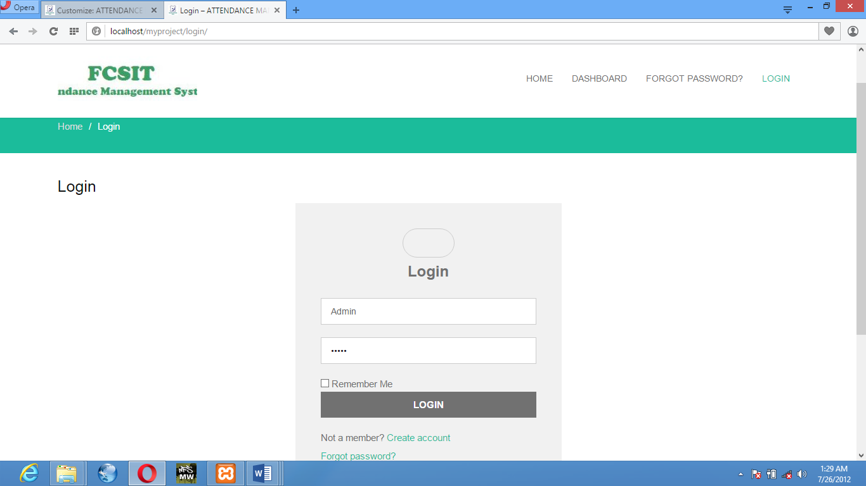

**Figure 1.1:** Login Interface

**Home Page:** After Login in this window will open as the homepage which will allow admin, teacher or student to navigate to his/her dashboard (Figure 4.2).

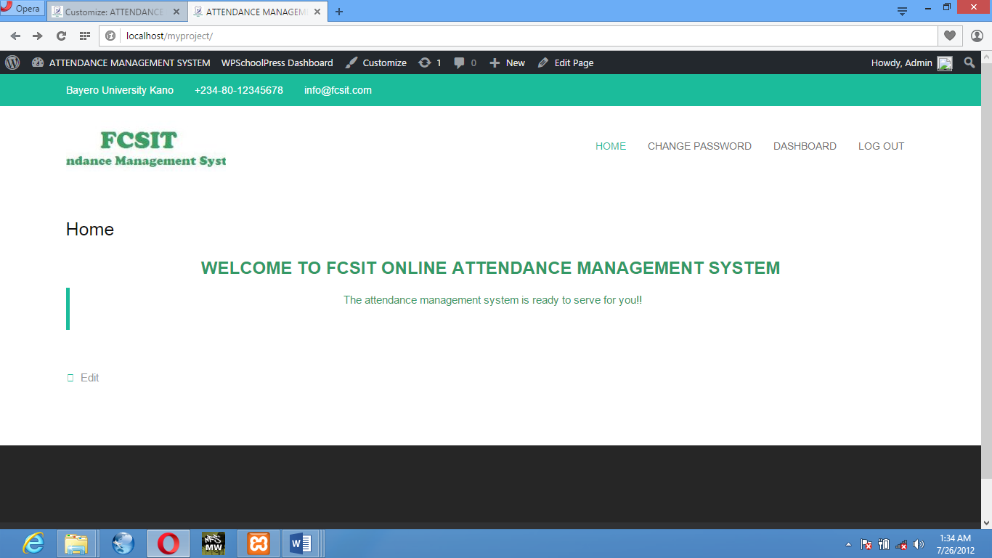

**Figure 1.2:** Homepage Interface

**Dashboard:** The window that allows admin to

* Add Student
* Add Teacher
* Add parent
* Add Subject
* Add Class
* Check Attendance
* Create/Check Event
* Send Notification

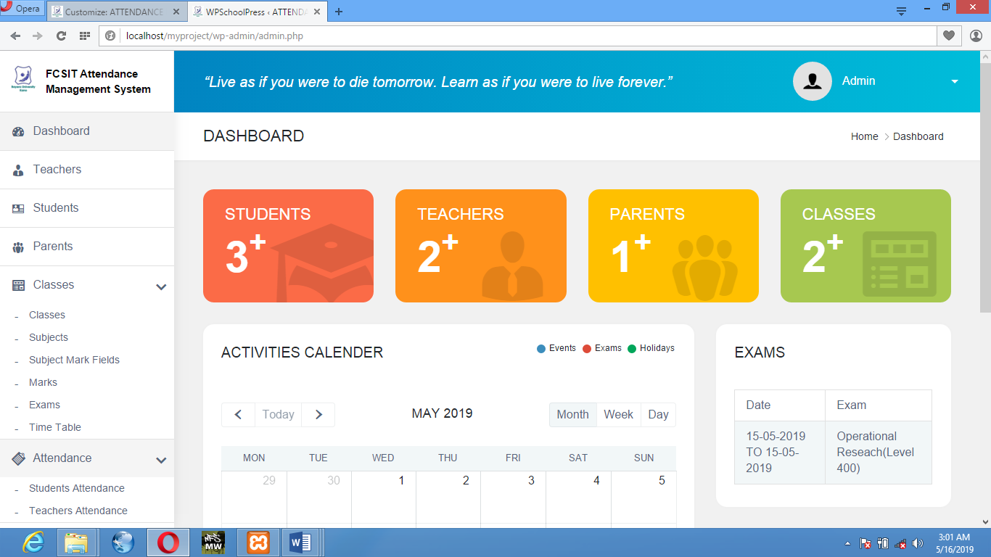

**Figure 1.3:** Dashboard Interface

**ADD STUDENT:** The window that allow admin to add student, view student or edit his profile if needed.

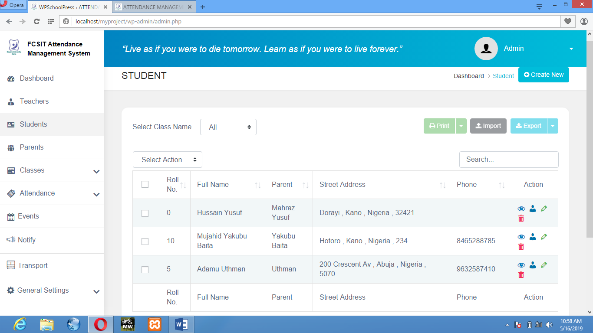

**Figure 1.4:** Student list

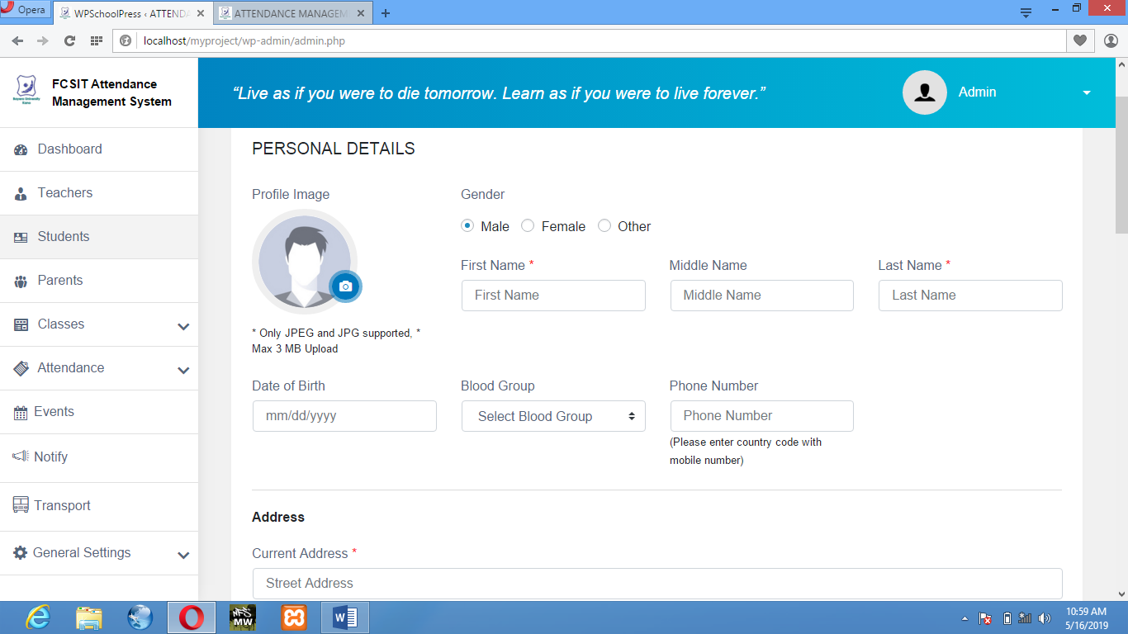

**Figure 1.1.1:** Add Student personal details

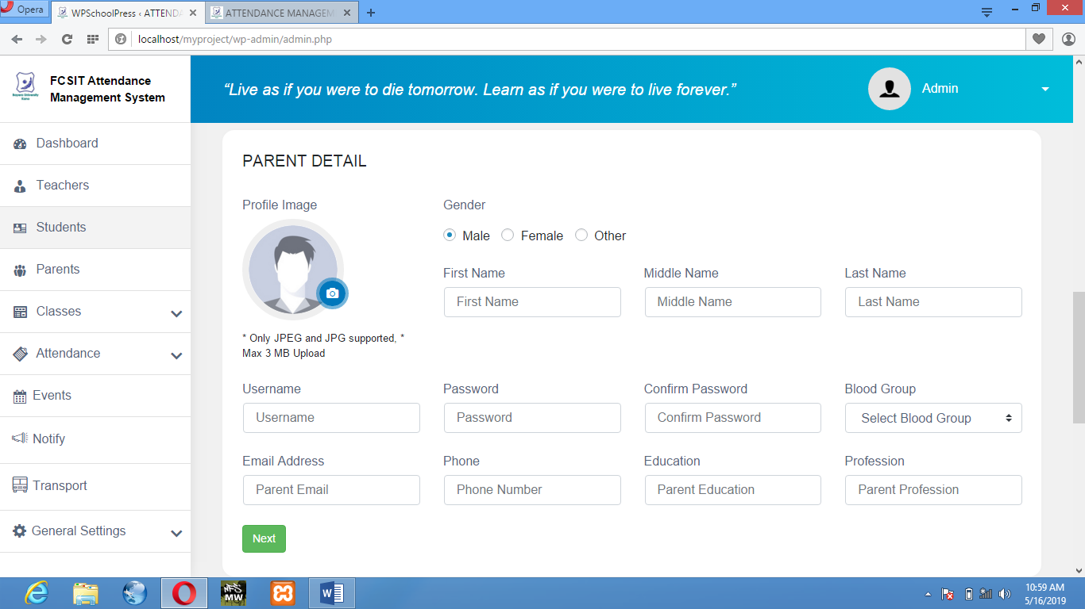

**Figure 1.1.2:** Add Student parent details

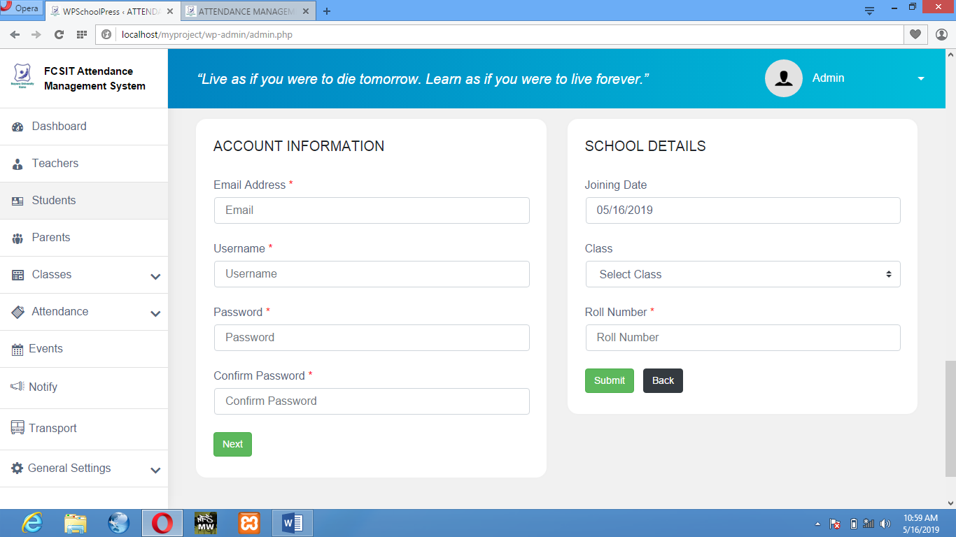

**Figure 1.1.3:** Add Student Account Info & School details.

**Figure 1.1.4:** Student Overview

**ADD SUBJECT:** This window allows admin to add/remove subject for a class to a specific teacher.

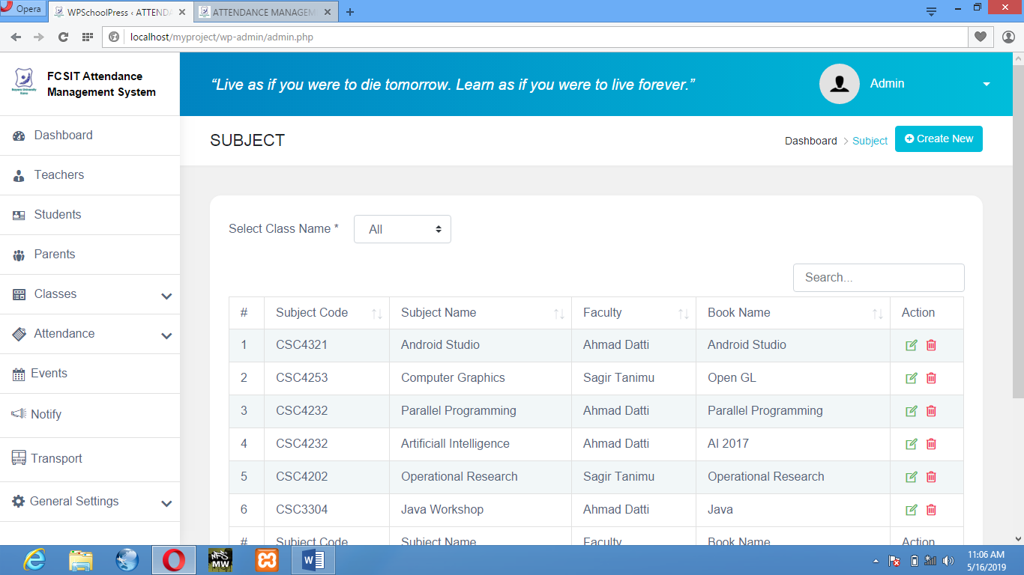

**Figure 1.2:** View Subject

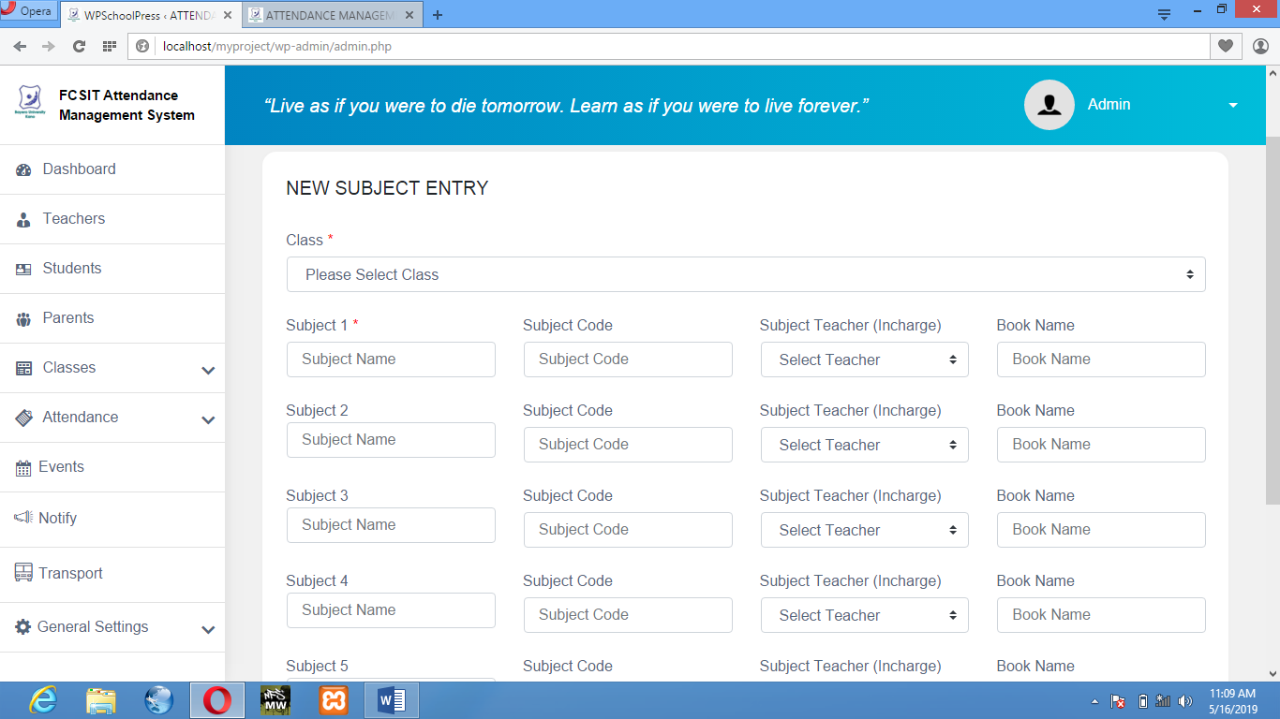

**Figure 1.2.1:** Add Subject

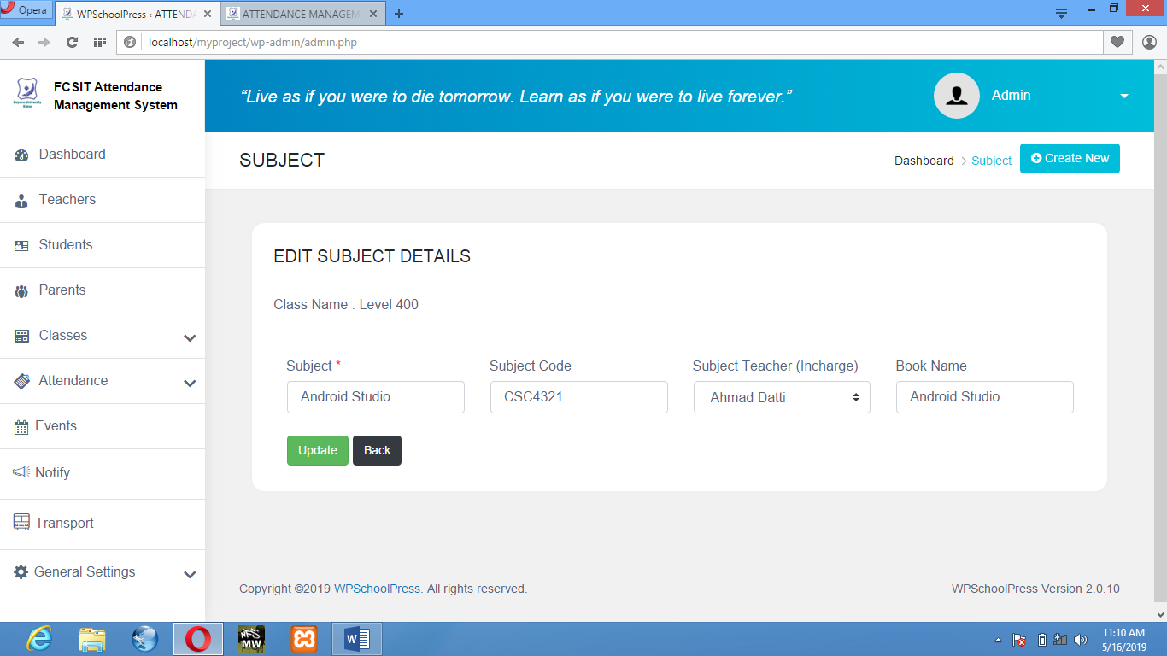

**Figure 1.2.2:** Edit Subject Details.

**CHECK ATTENDANCE:** This window will allow Admin/Teachers to add/view attendance for a Teachers/Students.

* STUDENT ATTENDANCE:

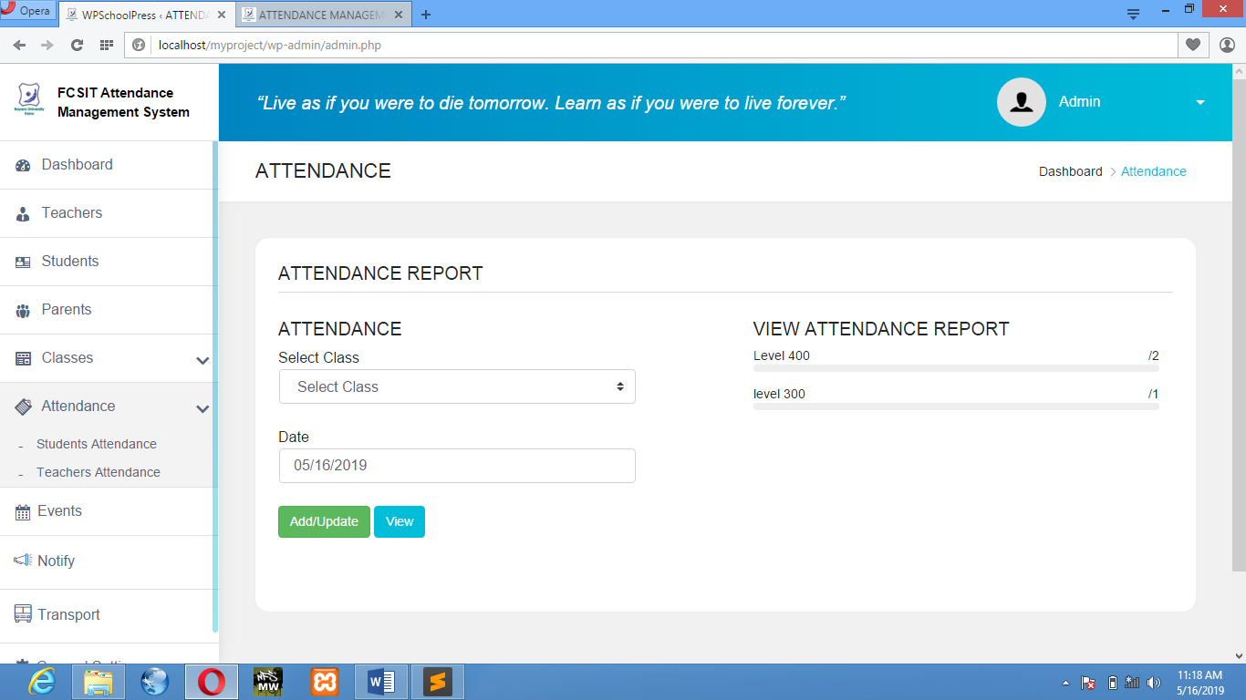

**Figure 1.3:** Attendance Report

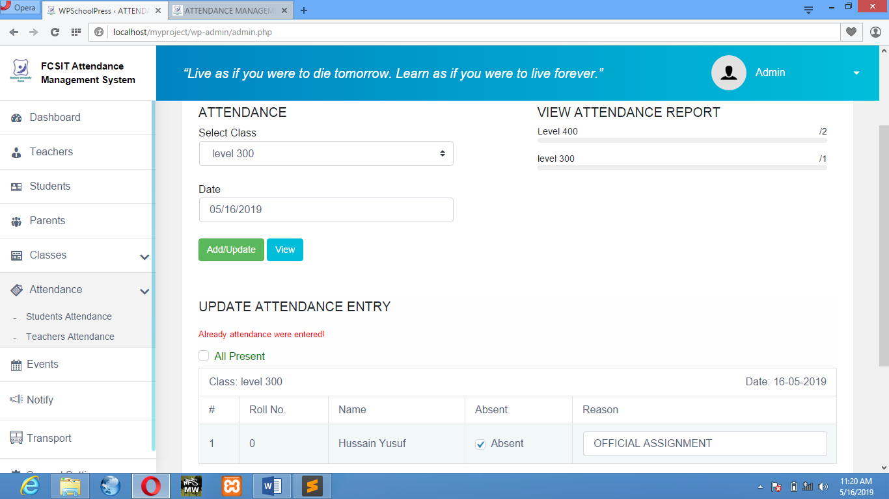

**Figure 1.3.1:** Add/Update Attendance

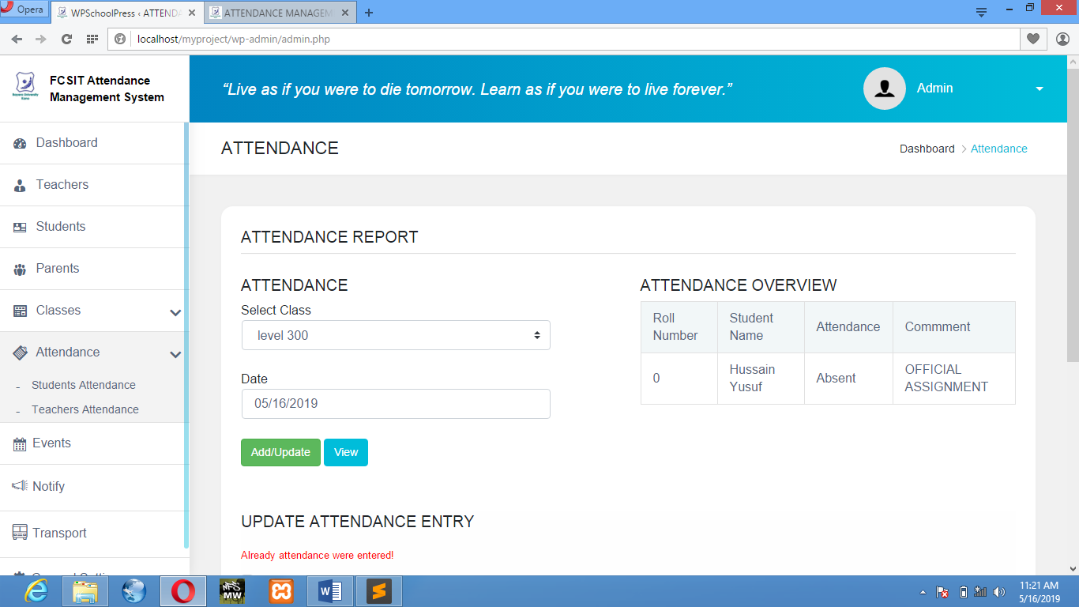

**Figure 1.3.2:** Attendance Overview

* TEACHERS ATTENDANCE

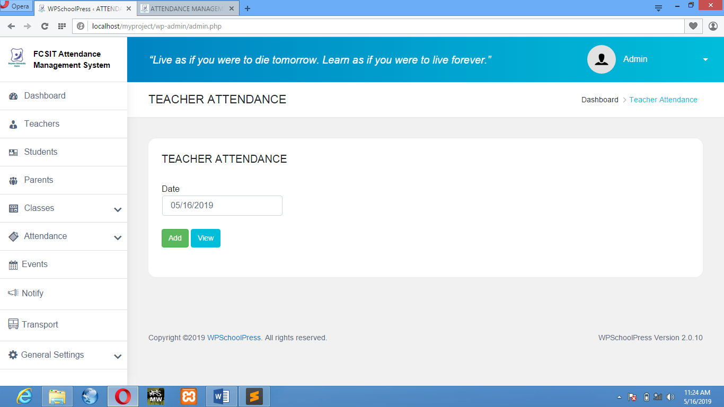

**Figure 1.4:** Teachers Attendance

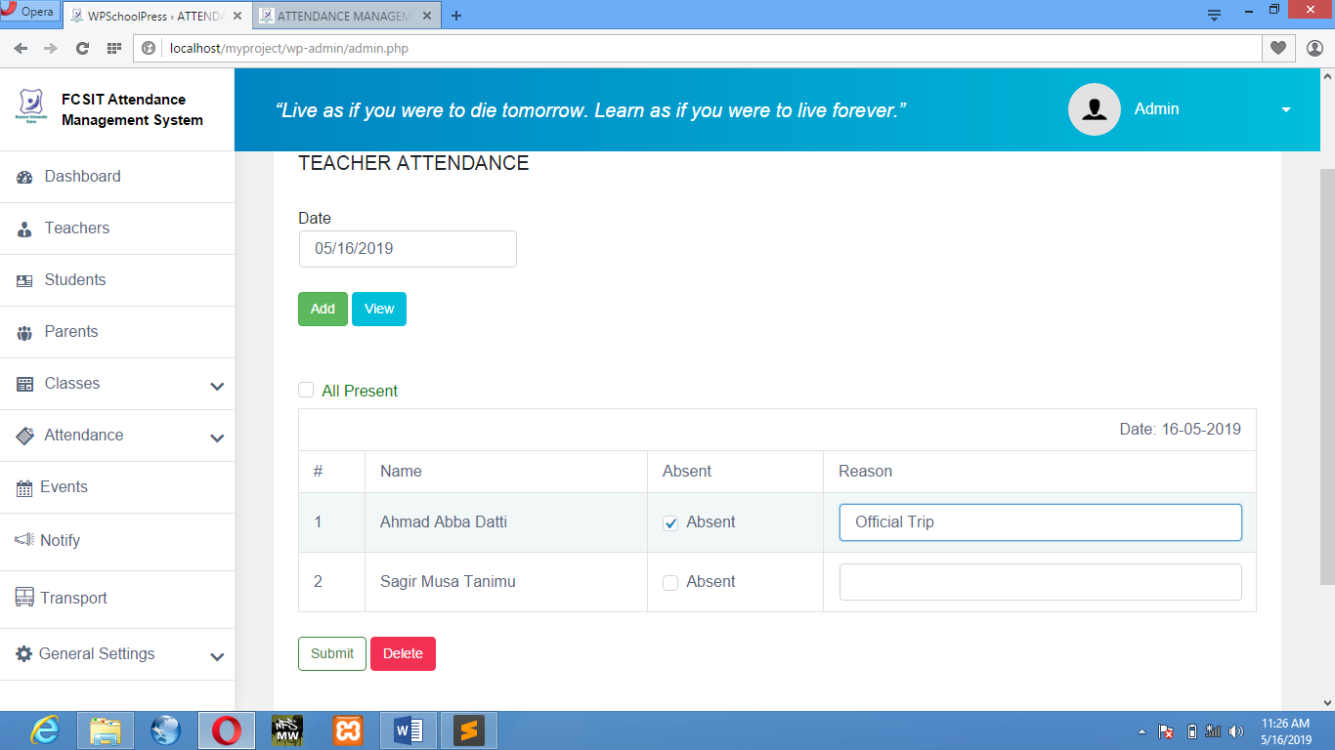

**Figure 1.4.1:** Add Teachers Attendance

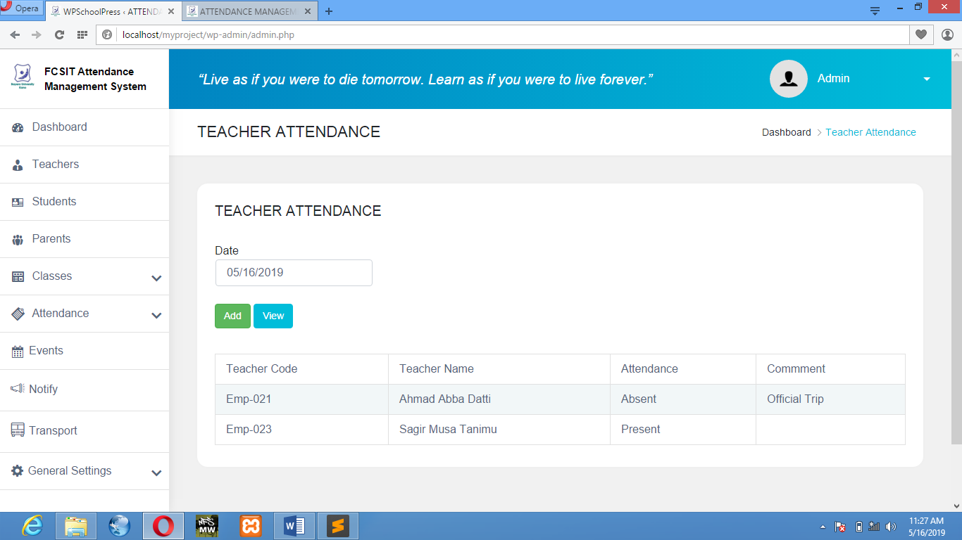

**Figure 1.4.2:** Teachers Attendance Overview

**ADD EVENT:** This window will allow Admin, Teachers or Students to add/check event of a specific day.

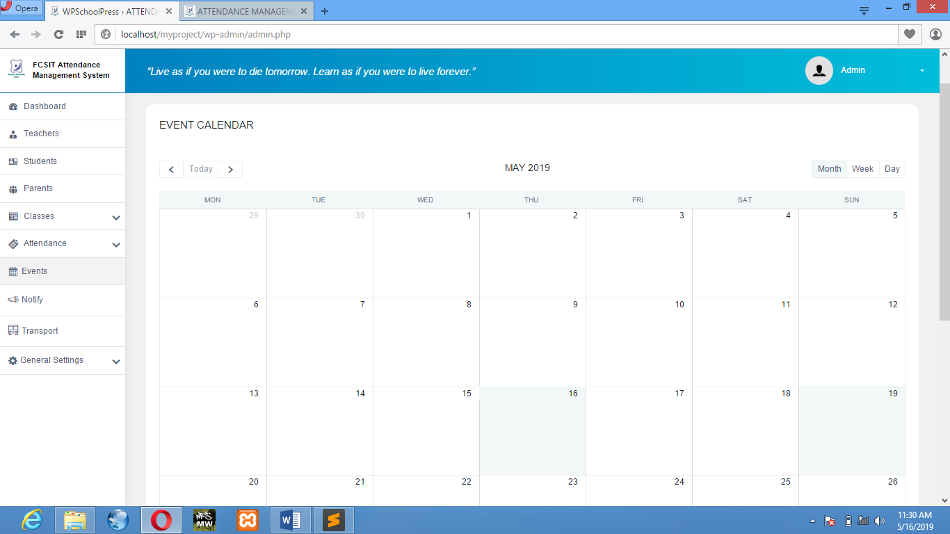

**Figure 1.5:** Event Calendar

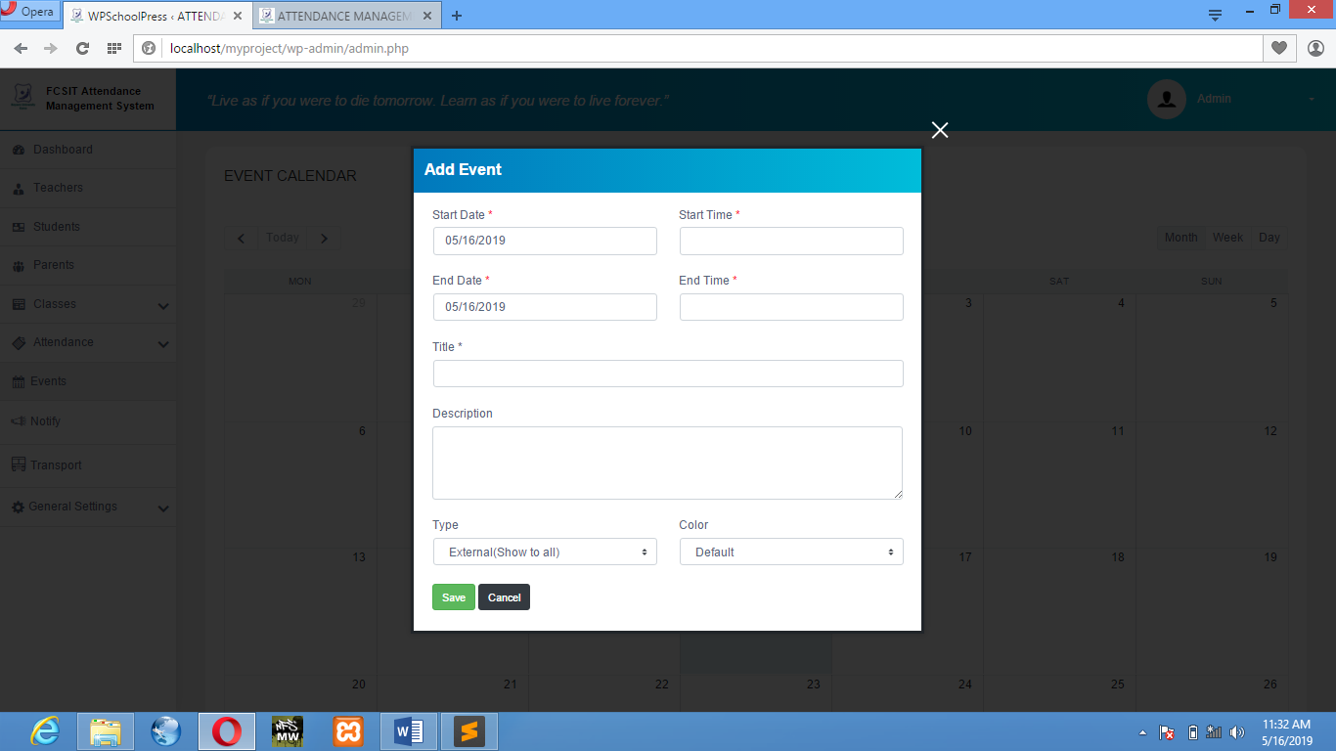

**Figure 1.5.1:** Add Event

**NOTIFICATION:** This windows allow the admin send notification to the student either by SMS/Email.

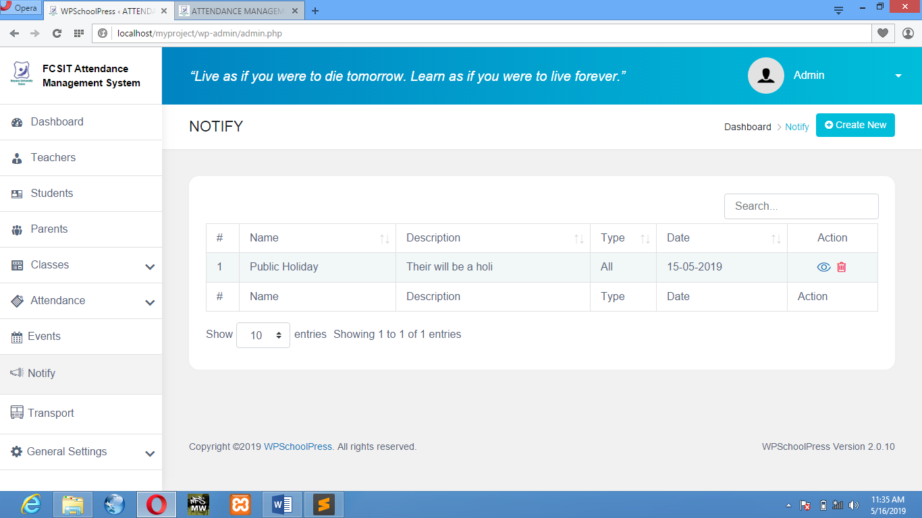

**Figure 1.6:** Notification Overview

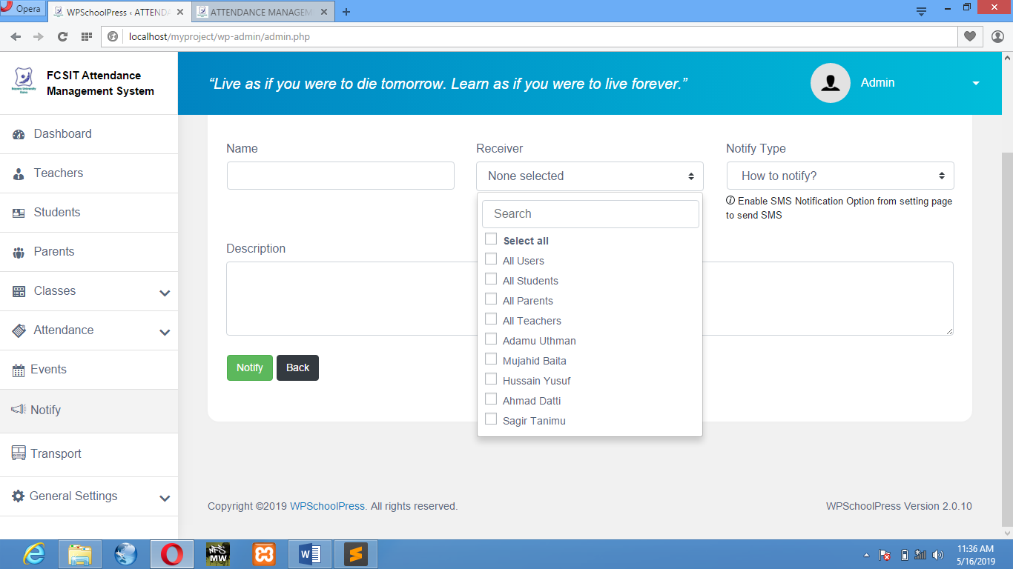

**Figure 1.6.1:** Create/Send Notification

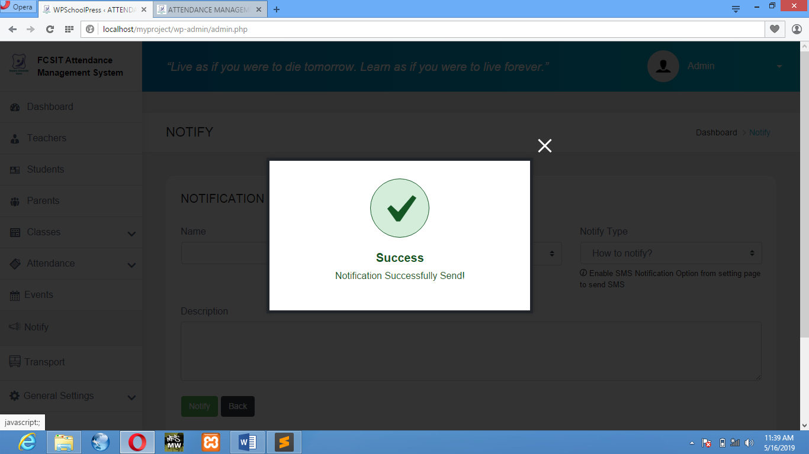

**Figure 1.6.2:** Notification Send Successful

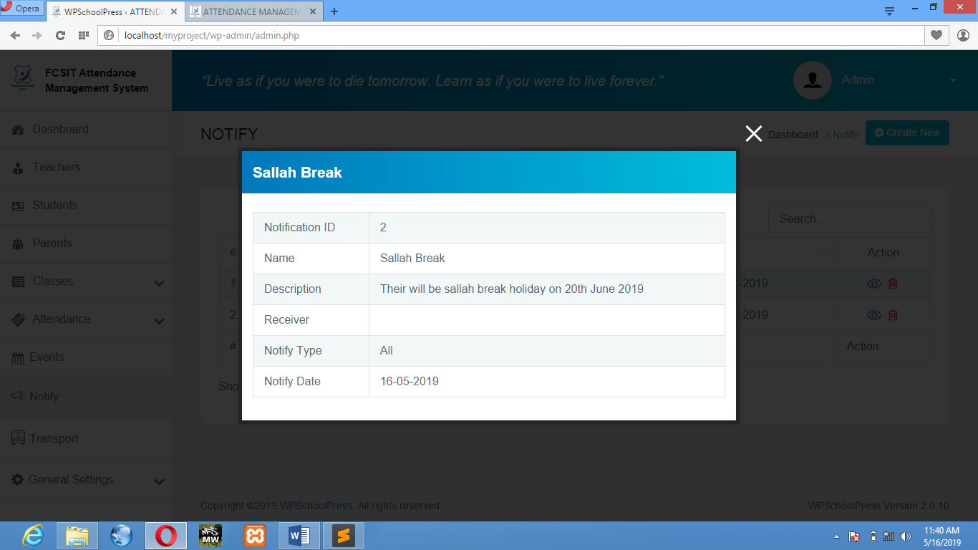

**Figure 1.6.3:** Notification Overview

* 1. SYSTEM TESTING

System testing is to check each step of the program to make sure that the designed software is working properly. The system was tested by inserting the admin username and password, then registering some people where the system excellently saved their information in the database, and it was saved successfully. Then a check attendance of student to confirm the process.

**4.3.1 Unit Testing**

The software interface and program unit functionalities of the system are tested to check how each is working (Table 4.1).

**Table 4.1 Unit Testing**

|  |  |  |
| --- | --- | --- |
| **Test Cases** | **Explanation** | **Result** |
| LOGIN | To check if only admin and teacher and student will be able to login after filling in the correct details in the available fields. Check if it was successful | pass |
| PREVIEW | To check if the admin and doctor will be able to visit their respective dashboard | Pass |
| CHECK ATTENDANCE | To check if the admin and teacher will be able to check the attendance system. Check if it was successful | Pass |
| ADD MEMBERS | To check if the admin can add students of different classes and teachers of different classes. Check if it was successful | Pass |
| CHECK EVENT | To check if the admin, teacher or student can check event. If it was successful | Pass |

**4.3.2 Integration Testing**

Integration testing is the next phase in system testing. The links interactions between MySQL or one activity and another were tested and everything was working well (Table 4.2).

**Table 4.2 Integration Testing**

|  |  |  |  |  |  |
| --- | --- | --- | --- | --- | --- |
| **Test Case ID** | **Test Case Objectives** | **Test Case Description** | **Input** | **Expected Output** | **Results** |
|  | To check the interface link between the login page and the home page. | Click on the LOGIN button. | Button clicked. | To be directed to the home page. | Pass |
| Button not clicked. | Remains unchanged. | Pass |
|  | To check the interface link between the home page and the Dashboard page. | Click on the Dashboard button. | Button clicked. | To be directed to the Dashboard. | Pass |
| Button not clicked | Remains unchanged. | Pass |
|  | To check the interface link between the Dashboard page and Attendance page | Click on Attendance button. | Button clicked. | To be directed to the Attendance page. | Pass |
| Button not clicked. | Remains unchanged. | Pass |
|  | Check the interface link between the Attendance page and View/Add Attendance. | Click on View/Add button. | Button clicked. | To be directed to View/Add Attendance window. | Pass |
| Button not clicked. | Remains unchanged | Pass |

**CHAPTER FIVE**

SUMMARY, CONCLUSION AND RECOMMENDATION

**5.1 SUMMARY**

This project a software for online Attendance Management System is developed after reviewing and analyzing the existing manual system at the investigation stage and a Use Case diagram to determine the actors of the system.

The design is implemented using wordpress, MYSQL for database and XAMPP as the offline local server. The web application starts with login which contains Admin, teachers or student login, then the Home Page where Admin, teachers or students can either click on Dashboard to view their respective dashboard.

**5.2 CONCLUSION**

The Attendance Management System is developed using Wordpress framework fully meets the objectives of the system which it has been developed. The system has reached a steady state where all bugs have been eliminated. The system is operated at a high level of efficiency and all the teachers and user associated with the system understands its advantage. The system solves the problem. It was intended to solve as requirement specification.

**5.3 RECOMMENDATION**

As a result of the finding made during the analysis and design stages of this research work. In order to improve the effectiveness of the site to its greater height and full potential, its recommended that the following features should be added for future expansion of this project.

* **E- Learning (Virtual Classes)**
* **A website for student forums**
* **Online Tutorial Classes**
* **Online Quiz/Exams**

For the effective usage of this software and have good management of it, it is necessary to provide computer to the vital registration centers and staff should be trained to acquire knowledge on how to use the computer and new system. So that the current system needs to be change in order to meet global standard and modern challenges of information technology.